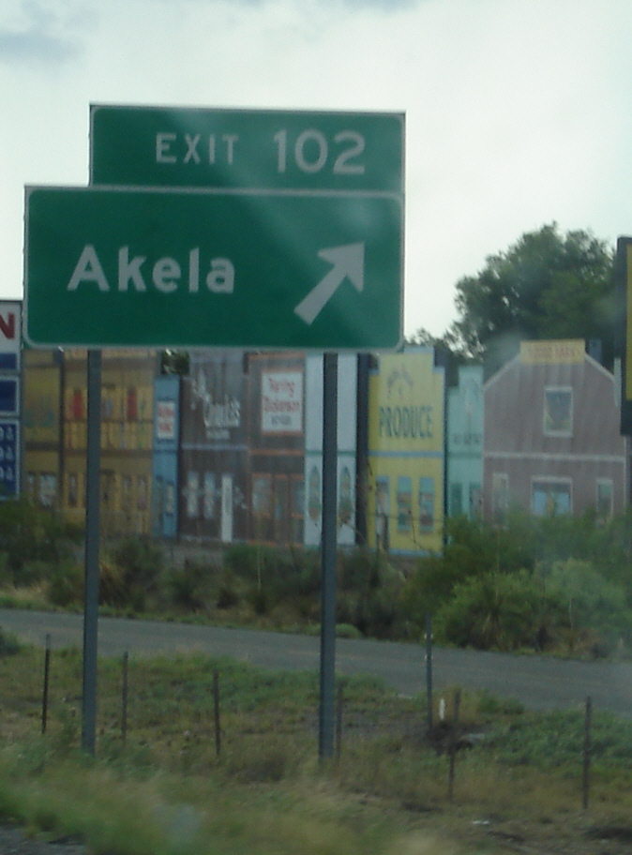
In Kipling’s The Jungle Book, Akela is the wise old leader of the wolf pack that raised the boy Mowgli. In Cub Scouting, which takes many themes from the Jungle Book, Akela is any wise leader: the Cubmaster and Den Leaders of course, but also a boy’s teacher and most importantly, you, the parents.
We have planned what we think is a great program for this year, but we welcome your ideas and suggestions and your participation -- the boys need the help of every Akela in the Pack. We invite you to take a detour off the highway of your regular life and make a difference in the life of all the boys of Pack 608.
Jesse Fenter, Pack Committee Chair jfenter@hotmail.com
Ben Neill, Cubmaster benneill5@yahoo.com
Please note: All dates and locations are tentative – check the Pack website, watch your email, or contact your Den Leader for final details.
September 2010
- Recruiting Table at Back-to-school night
- Poway Days Parade: September 18
  - Recruiting and/or fundraising table at Community Picnic after parade
- Pack Meeting / Roundup: September 21, Midland lunch area
  - Make rope for new Scouts
  - Game
  - Popcorn kickoff
  - Flags: Bear Den 1
- Popcorn site sales
- Trail Maintenance: Webelos Cobras Den
- Parent / Committee Meeting: September 28, Old Poway Park

October 2010
- Pack Family Camp at Indian Hills: October 8 - 10
  - Hike
  - Zip line and BMX track
  - Campfire program
  - Flags: Wolf Den 2
- Popcorn site sales
- Popcorn wrap-up October 19th – all money due
- Trail Maintenance: Bear Den 1
- Parent / Committee Meeting: October 26, Old Poway Park

November 2010
- Pack Meeting: November 16
  - Animal theme – search-and-rescue dogs, Police dogs, or 4H
  - Introduce service project (Collecting pet food for AniMeals program)
  - Flags: Wolf Den 3
- Webelos Woods (for Webelos (4th-5th grades only): November 5 -- 7
- Trail Maintenance: Wolf Den 2
- Parent / Committee Meeting: November 17, Old Poway Park

December 2010
- Pack Meeting: Friday December 17, Midland MPR
  - Movie – “Up”
  - Hand out gift-wrapped Pinewood cars
    - Display of some of last year’s best cars
  - Collect pet food for AniMeals
  - Flags: Tiger Den 4
- Trail Maintenance: Wolf Den 3
- Parent / Committee Meeting: December 14 or January 4, Old Poway Park

January 2011
- Pinewood Derby workshop: January 8
- Pinewood Derby check-in: January 21
- Pinewood Derby: January 22, Community Center
  - Flags: Bear Den 1
- Trail Maintenance: Dragons Webelos II and Tiger Den 4
- Parent / Committee Meeting: January 25, Old Poway Park

February 2011
- Blue and Gold Banquet: February 11, Community Center
  - Catered again if finances allow
  - Flags: Webelos II Dragons
- Scout Sunday: February 13
  - Boys who attend church are encouraged to wear their uniforms
- Trail Maintenance: Bear Den 1 (and 2nd Tiger Den if there is one)
- Parent / Committee Meeting: February 22, Old Poway Park

March 2011
- Pack Meeting: March 15, Midland MPR
  - Arrow of Light ceremony for Webelos IIs
  - Uniform inspection
  - Flags: Webelos Cobra Den
- Kite flying (informal): Saturday March 13, Location TBD
- Scout Fair ticket sales
- Trail Maintenance: Wolf Den 2
- Parent / Committee Meeting: March 29, Old Poway Park

April 2011
- Pack Meeting: April 19, Midland lunch area
  - Differences Awareness game
  - Award Wolf and Webelos badges
  - Introduction to Summer Camps – Day Camp and Resident Camp
  - Flags: Wolf Den 2
- Scout Fair and San Diego 500, April 16 at Qualcomm Stadium
- Trail Maintenance: Wolf Den 3
- Parent / Committee Meeting: April 26, Old Poway Park

May 2011
- Jamboree on the Trail (JOTT) hike: May 7
- Pack Meeting: May 17, Midland lunch area
  - Award Tiger and Bear badges
  - Flags: Wolf Den 3
- Midland Carnival: date TBD. Water bottle rockets recruiting booth; litter pickup.
- Family Camp at Mataguay, Memorial Day weekend (informal)
- Trail Maintenance: Tiger Den 4
- Parent / Committee Meeting: May 31, Old Poway Park

June 2011
- Pack Picnic / promotion: Saturday June 11, Lake Poway
  - Cub-o-matic
  - Field day. 1 station to be run by each Den
  - Flags: Tiger Den 4
- Webelos Resident Camp – June 20 – 24?
- Trail Maintenance: Webelos Cobra Den
- Bicycle Rodeo: June 18 or July 9
- Parent / Committee Meeting: June 28, Old Poway Park

Trail Maintenance and Flag Ceremony Assignment:

Flag Ceremony |  |  | Trail Maintenance
September ’10 | Bear Den 1 |  | September ’10 | Cobras
October | Wolf Den 2 |  | October | Bear Den 1
November | Wolf Den 3 |  | November | Wolf Den 2
December | Tiger Den 4 |  | December | Wolf Den 3
January ’11 | Bear Den 1 |  | January ’11 | Dragons (+ Tiger Den 4)
February | Dragons |  | February | Bear Den 1 (+ Tiger Den x)
March | Cobras |  | March | Wolf Den 2
April | Wolf Den 2 |  | April | Wolf Den 3
May | Wolf Den 3 |  | May | Tiger Den 4
June | Tiger Den 4 |  | June | Cobras

