Cub Pack 608

Cub Scout Parent Guide
2010 – 2011

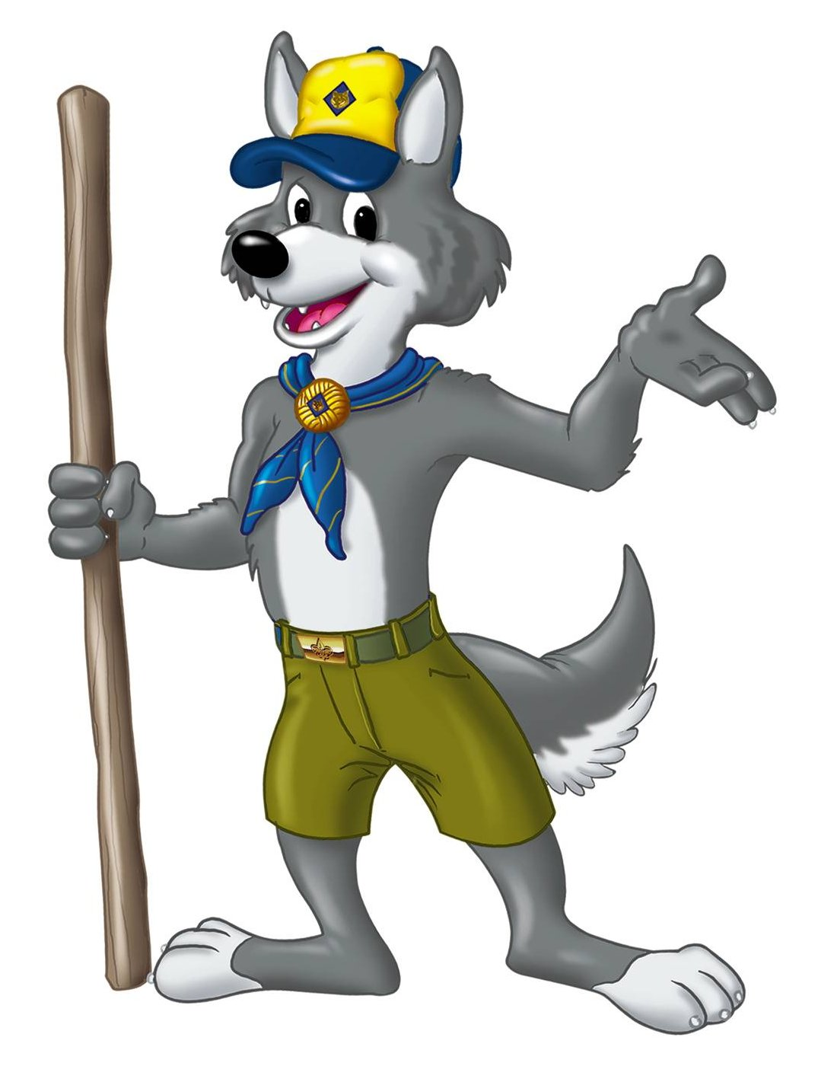

Welcome!
Welcome to Cub Scouts and Pack 608. Pack 608 has been in continuous existence at Midland Elementary since 1955, making us Poway’s oldest Cub Scout Pack.

Our Pack is made up of approximately 50 boys and their families, mostly from Midland Elementary School. Our Pack is open to all elementary school age boys; regardless of what school they attend. Cub Scouts are part of the Boy Scouts of America, and have a long tradition of providing lots of fun activities for young boys.

In Pack 608 we believe that Cub Scouting is fun, but it is fun with a purpose. Here is some information to help you understand how Pack 608 practices Cub Scouting.

The Purposes of Cub Scouting
Since 1930, the Boy Scouts of America has helped younger boys through Cub Scouting. It is a year-round family program designed for boys who are in the first grade through fifth grade (or 7 through 11 years of age). Parents, leaders, and organizations work together to achieve the purposes of Cub Scouting.
The 10 purposes of Cub Scouting are:
Character Development
Spiritual Growth
Good Citizenship
Sportsmanship and Fitness
Family Understanding
Respectful Relationships
Personal Achievement
Friendly Service
Fun and Adventure
Preparation for Boy Scouts

Organization
Cub Scout Pack 608 is made up of first grade through fifth grade boys. The boys are grouped into small groups (dens) of 4 to 8 boys. Each den has one or more adult leaders, and consists of boys in the same grade. First graders are Tiger Cubs, second graders are Wolf Cubs, third graders are Bear Cubs, and fourth and fifth graders are Webelos. Our website is: http://www.cubpacks.org/ca/cs/608/

Pack 608 is part of the Black Mountain District of the San Diego-Imperial Council of the Boy Scouts of America. There are over 300 councils in the United States. The Web site for our local council is: http://www.sdicbsa.org and our district Web site is http://www.sdicbsa.org/blackmountain/

Each Cub Scout pack is sponsored by an organization. Our chartered organization is the Knights of Columbus of Saint Gabriel’s Church. The chartered organization provides a representative who is the liaison between the pack and the organization.
Leadership
All adult leaders for Pack 608 must complete Youth Protection Guidelines (YPG) training (available on-line) and Cub Scout Leader Basic Training.

The Pack is run by the Pack Committee, which is headed by the Committee Chairman. In Pack 608, all adult leaders are committee members. The Committee meets once each month to plan pack meetings and other pack activities. Parents are always welcome and encouraged to attend these meetings.

The Cubmaster is in charge of the Pack meetings and reports to the Committee.

The Den Leaders are the ones who do the majority of the work, and who have the most fun. Den Leaders plan and organize den meetings, keep track of the boys' advancements, and attend leaders meetings (Committee meetings).

Parents play an important role in the pack. The leaders will do their best to provide a quality program, but all the leaders in Pack 608 are volunteers and have many other obligations. We depend on parents to help provide the good program we have.

We ask every parent to help the pack in some capacity. You are encouraged to assist in your son’s den and/or to help with at least one pack activity a year (e.g. Pinewood Derby, Blue and Gold Banquet, a campout). A volunteer sheet is at the back of this handbook. A parent should attend each pack meeting with the Cub Scout. Parents are welcome to attend any Pack, District or Council meeting.

All parents need to get Youth Protection Guideline training from BSA. This will allow more flexibility when taking dens on field trips. Training is available on-line at www.sdicbsa.org. Look under “Training-> Cub Scout Leader-> Class Schedules”, then click on “Youth Protection Guidelines. Our Council is “Black Mountain” and our unit is “Pack 608”.

Meetings
Den meetings: Most dens meet 2-3 times per month, in addition to the Pack Meeting or activity. At least two YPG-trained adults are required to be present at all times. The Den Leader and Den parents decide the exact schedule of the meetings and plan the activities for each meeting.
Pack meetings: Pack meetings or activities are held once a month. Pack meetings are for all the boys of Pack 608. We expect a parent or the whole family to attend the pack meeting. Pack meetings will usually be held in the Midland Elementary MPR or outdoor lunch area. Be sure to check with your Den Leader or the Pack website (http://www.cubpacks.org/ca/cs/608/) to confirm dates, times and location.

Special Events: There are many special events: family campouts, field trips, parade, etc. These often replace a Pack Meeting. For instance in January we will have a Pinewood Derby instead of a Pack Meeting.

Pack Committee Meetings: Leaders and Parents of Pack 608 discuss organizational matters, future events and exchange ideas. All parents are encouraged to attend. These meetings are generally held the last Tuesday of each month at the Parlor Room in Old Poway Park (near the Park office).

Roundtables: Roundtables are meetings sponsored by the District to exchange ideas and announcements. All Pack 608 Leaders are encouraged to attend Roundtables. Parents are also welcome. These are held the second Thursday evening of each month at the LDS Stake Center, 15750 Bernardo Heights Parkway.
Ranks and Advancement
Boys work their way through Cub Scouts doing activities that are fun and challenging. The activities are carefully chosen to be age-appropriate and “hands-on”. They cover many aspects of life, and are designed to:
- Influence a boy's character development and spiritual growth.
- Develop habits and attitudes of good citizenship.
- Encourage good sportsmanship and pride in growing strong in mind and body.
- Improve understanding within the family.
- Strengthen a boy's ability to get along with others.
- Foster a sense of personal achievement by developing new interests and skills.
- Show a boy how to be helpful and do his best.
- Provide fun and exciting new things to do.
In addition to the activities that contribute to advancement in rank, the boys can earn belt loops, pins and letters in the optional Academics and Sports Program. The purpose of these awards is to encourage Scouts to try new activities and learn new skills, or to improve those skills they already have. As in most activities in Cub Scouting, this is not meant to be a highly competitive program; instead the boys are encouraged to "do their best".

Cubs at each level (Tiger Cubs, Wolf, Bear, and Webelos) work on age-appropriate requirements to earn the patch (“badge”) for their Rank. Participation of an adult partner is required for all Tiger Cub activities and is strongly encouraged for all other Ranks.

Bobcat: The Bobcat badge is an introduction for boys who join Cub Scouting. All boys must complete the Bobcat before receiving any other awards.

Tiger Cub: The Tiger Cub program is for first-grade (or age 7) boys and their adult partners. There are five Tiger Cub achievement areas. The Tiger Cub, working with his adult partner, completes 15 requirements within these areas to earn the Tiger Cub badge. These requirements consist of an exciting series of indoor and outdoor activities just right for a boy in the first grade.

Wolf. The Wolf program is for boys who have completed first grade (or are age 8). To earn the Wolf badge, a boy must pass 12 achievements involving simple physical and mental skills.

Bear. The Bear rank is for boys who have completed second grade (or are age 9). There are 24 Bear achievements in four categories. The Cub Scout must complete 12 of these to earn the Bear badge. These requirements are somewhat more difficult and challenging than those for Wolf rank.

Webelos: This program is for boys who have completed third grade (or are ages 10-11). This is the first step in his transition from the Cub Scouts to Boy Scouts. As he completes the requirements found in the Webelos Handbook, he will work on activity badges, attend meetings led by adults, and become familiar with the Boy Scout requirements—all-leading to the Arrow of Light Award. The Arrow of Light is the highest rank in Cub Scouts; it is the only Cub Scout badge that may be worn on a Boy Scout uniform.

Other: Any Wolf, Bear or Webelos Scout can earn the Cub Scout World Conservation Award, Outdoor Activity Badge, or any of a number of Religious emblems sponsored by their place of worship.

2010-2011 Pack Activities

Pack 608 has an exciting program planned for this year. The exact dates will be provided separately. You can also check dates, times and locations on our website (http://www.cubpacks.org/ca/cs/608/)
- September: “Roundup” (recruiting drive), and the kick off to our Annual Popcorn Sale. Selling popcorn is our major fundraiser of the year. We will have prizes for the top selling Cubs and Dens.
- October: Family camping – Indian Hills. Also, wrap up our Popcorn Sale
- November: Pack Meeting. Most Pack Meetings include a program; Pack Meeting programs have included a magician, 4H animals, Mad Science, Raptor Rescue, etc.
- December: Pack Meeting.
- January: Pinewood Derby.
- February: Blue and Gold Banquet to celebrate Cub Scouting.
- March: Arrow of Light Ceremony and Bridging to Boy Scouts for our 2nd year Webelos.
- April: Pack Meeting.
- May: Pack Meeting.
- Midland Carnival – our Pack does cleanup during the Carnival as a service, and runs a booth.
- June: Promotion Ceremony (where boys advance to the next Rank) and end of year Picnic.
- Summer: Summertime activities usually include a hike, skating or rock climbing, a Padres or Storm game, fishing and a camping trip.
- Trail Cleanup – Each month one of our dens maintains the Tierra Bonita Hiking trail in Poway.

Paperwork, Fees, Uniforms

Registration and Dues: The annual dues are $77.00 ($15 goes to BSA, $12.00 for Boys Life Subscription, $50 stays with pack). If you have a second boy, you may reduce his fee by $12.00 ($65.00) if you do not want a second copy of Boys Life. Dues are due at the October pack meeting. Since the membership period is the calendar year, boys joining in the fall also pay a pro-rated amount for National dues for the last months of the year. See the Chart below. Note that the dues pay for only a portion of our programs; profits from popcorn sales provide some of our funding and allow us to keep the dues relatively low. All checks are payable to “Pack 608”.

New Scouts: Total $111.00 Payment due at time of registration:
$20.00 dues to Boy Scouts of America (Good to Dec 2011)
$75.00 dues to Pack ($25 for 2010; $50 for 2011)
$16.00 Pro-rated Boys Life

Returning Scouts: $77.00 Payment due to pack at October pack meeting:
$15.00 dues to Boy Scouts of America (Jan – Dec 2011)
$50.00 dues to Pack
$12.00 annual Boys Life Subscription

Pack 608 pays the registration fees for its adult leaders.

Uniforms: Cub scouts buy their own uniform, including council patch, pack and den numerals. The pack provides award badges. Tiger, Wolf and Bear Cubs use the blue Cub Scout uniform (with rank-specific neckerchiefs), while Webelos may wear the blue uniform, or the tan Boy Scout uniform shirt with blue shoulder loops. The staff at the Scout store can help you buy the right stuff including the right color for the neckerchief. Pack 608 has a “waist-up” uniform policy; we accept any dark pants or jeans. A uniform inspection is part of one of our pack meetings; we expect the boys to have their uniforms before then.

Pack 608 also has Pack t-shirts available; these can be worn at campouts, fishing derby, pinewood derby workshop or any event where the uniform may get ruined.

Uniform Guidelines
Event | T-shirt or Formal Uniform
Any Award Ceremony | Formal Uniform
Blue and Gold Banquet | Formal Uniform
Camping | T-shirt
Christmas Caroling | Formal Uniform
Field Trip to Police Station, Fire Station, etc. | Formal Uniform
Fishing | T-shirt
Flag Ceremony | Formal Uniform
Midland Carnival – working | Formal Uniform
Pack Meeting | Formal Uniform
Parade | Formal Uniform
Pinewood Derby | Formal Uniform
Pinewood Derby Workshop | T-shirt
Pro baseball games | Formal Uniform
School on Pack Meeting Day | Formal Uniform
Scout Jamboree | Formal Uniform
Selling Popcorn | Formal Uniform
Trail Cleanup | T-shirt
Webelos Woods | T-shirt

Uniforms can be bought at the Scout Shop at the Council headquarters in Balboa Park, 1207 Upas Street. The Scout Shop employees can help you get everything you need. They are also available on-line at www.scouting.org

Handbooks: Pack 608 provides Tiger, Wolf, Bear, and Webelos books. We recommend that parents read the books for their child's age group cover-to-cover and follow your boy’s progress carefully. Every handbook has a parent guide at the beginning that you are required to complete with your child.

Recruiting: If your boy has a friend who is interested in Cub Scouts, bring him to any pack or den meeting. Don't wait for the next year's membership night. Any Cub who gets a friend to join earns a recruiter patch that is worn below the right pocket.
Insignia Placement on the Uniform
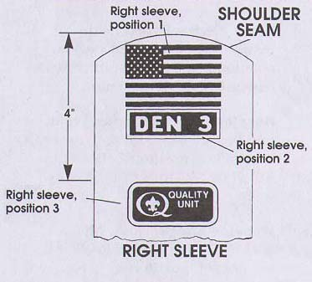 |  | Left Sleeve
Right Pocket |  | Left pocket
Right Sleeve. Wear U.S. flag, den numeral, and Quality Unit Award as shown. Webelos Scouts may wear den emblem instead of den numeral. Webelos Scouts wear the Webelos colors immediately below and touching den numeral or emblem. Wear Webelos activity badges on the colors.
Left Sleeve. Wear council patch and pack numeral as shown. The veteran unit insignia bar (50 years) is worn centered below the council patch and above the numeral, and touches both.
Left Pocket. The World Crest is worn centered between the left shoulder seam and the top of the left pocket. Cub Scouts wear badges of rank as shown: Tiger Cub, Bobcat, Wolf, and Bear. Gold Arrow Points are worn beneath the pocket and below the badge for which they were earned. Silver Arrow Points are worn below the Gold Arrow Points in double rows. Once a Webelos Scout has earned the Webelos badge, only that badge is worn. Wear service stars (with gold background disks) centered just above medals or knots, or 3⁄8 inch above seam. The only knots worn by Cub Scouts are the religious emblem knot and a lifesaving or meritorious award knot.
Right Pocket. Progress Toward Ranks (with thong and beads) for Cub Scouts or Compass Points emblem for Webelos Scouts is fastened to button under flap of right pocket and flap rebuttoned. The Outdoor Activity Award is worn on the pocket flap. The National Summertime Award is pinned centered on the flap.
Neckerchief: The neckerchief is worn under the shirt collar, tightly rolled to within about 6” of the point. Each rank has its own neckerchief color: Tiger Cubs wear an orange neckerchief; Wolfs wear yellow; Bears blue; and Webelos plaid.
Belt: Cub Scouts wear the blue webbing belt. Hint – adjust the belt so that the brass end is close to the buckle when worn, by opening the latch on the back of the buckle and pulling the extra through. (The extra may be trimmed if you think your boy will not grow into it.)
Vest: Most boys also purchase a red vest to hold the many patches from camps and activities. The Pack provides a round Pack 608 patch for the back of the vest, and boys earn “arcs” to go around it for participating in different activities on Pack camping trips.
2008-2009 Pack 608 Leadership Positions

Cubmaster | Ben Neill | 748-4193 | benneill5@yahoo.com
Committee Chair | Jesse Fenter | 883-2483 | jfenter@hotmail.com
Treasurer | Lon Anderson | 668-0896 | anarajul@hotmail.com
Secretary-Charter | Amy Anderson / Open | 668-0896 | amyanderson531@hotmail.com
Achievements Chair | Tracee Ellis | 231-3084 | traceeellis2@yahoo.com
Blue & Gold Banquet Co-Chairs | Anne Marie Fenter  JT Thiry | 883-2483 | annemariefenter@live.com  jtandcd@gmail.com
Camping Coordinator | Laura Oh | 513-2766 | sunnypurplewater@yahoo.com
Communication Coordinator | Sami Gaudreau
Pinewood Derby Chair | Don Allie | 883-2321 | dballie2000@yahoo.com
Popcorn Kernel | Marc Lawrence | 486-4433 | mbl2003@cox.net
Recruiting Chair | Open
Trail Cleanup Liaison with City | Jesse Fenter | 883-2483 | jfenter@hotmail.com
Pack Historian | Bethany Allie | 883-2321 | Dballie2000@yahoo.com
T-shirts | Bethany Allie | 883-2321 | dballie2000@yahoo.com
Cans For Critters Chair | Anne Marie Fenter | 883-2483 | annemariefenter@live.com
Volunteer Coordinator | Open
Webmaster | John Hartvig | 679-0463 | john@hartvigerne.dk

Den Leaders

RANK | DEN | LEADER | PHONE | EMAIL
Tigers | Den 4 | Brian Wilcox |  | aimeewilcox@gmail.com
Wolf | Den 2  Den 3 | Jennifer Dodd  Sheila Cram |  | sheilais@hotmail.com
Bear | Den 1 | Amy Anderson/  Anne Marie Fenter | 668-0896  883-2483 | amyanderson531@hotmail.com  annemariefenter@live.com
Webelos 1 | Cobras | Don Allie/  Marc Lawrence/  John Hartvig | 883-2321  486-4433  679-0463 | Dballie2000@yahoo.com  Mbl2003@cox.net  john@hartvigerne.dk
Webelos 2 | Dragons | Craig Dickson/ Brian Bethge | 748-1259  513-8415 | Cdickson12@gmail.com  bbethge@cox.net

2010-2011 Volunteer Opportunities

Please fill in and return this form with your Cub Scout Application

Cub Scout name(s): ___________________________________________
_____________________________________

Parent name(s): ________________________________
________________________________

Phone number(s): ________________________________
Email address(es): ________________________________

_____ I will help Pack by volunteering for items marked below.

_____ I would like to learn more about the marked volunteer opportunities.

_____ Den Leader or Assistant Den Leader
_____ Pack Secretary
_____ Pack Volunteer Coordinator
_____ Pack Training coordinator
_____ Pack Special Activities Chair Person
_____ Pack Publicity Chairperson
_____ Pack Recruiting Coordinator

If unable to make the full-year commitment for a leadership position, parents should assist with the planning or running of at least one event:

_____ Pinewood Derby Team Member -- workshop, officiating, setup (track, computers, etc.), trophies and certificates
_____ Blue and Gold Banquet Team Member -- Decorations, set-up, general coordination
_____ Recruiting –
_____ Fall roundup
_____ Midland Carnival booth staffing
_____ Midland Carnival cleanup services
_____ Summertime activity flyers
_____ Arrow of Light – Crafting Arrows for the awards

